(SECJ1013) PROGRAMMING TECHNIQUE 1
SEM 1, SESSION 2023/2024
LAB EXERCISE 3 (4%)

INSTRUCTIONS TO THE STUDENTS
- This exercise must be done individually.
- Any form of plagiarism is NOT ALLOWED. Students who copied other students' assignments will get ZERO marks (both parties, students who copied, and students who shared their work).

SUBMISSION PROCEDURE
- Please submit this exercise no later than December 21, 2023, Thursday (1 PM MYT).
- Only hardcopy is accepted for this submission with handwriting (at my office – n28a, level 2, room 02-31-01).

Fill your information here:

Name

Matric Number

Year / Course

Section

SET 1
The following program code has errors. Locate the errors.
Line | C++ Codes
1  2  3  4  5  6  7  8  9  10  11  12  13  14  15  16  17  18  19  20  21  22  23  24  25  26  27  28  29  30  31  32  33  34  35  36  37  38  39  40  41  42  43  44  45  46  47  48  49  50  51  52  53  54  55  56  57  58  59  60  61  62  63  64  65  66  67  68  69  70  71  72 | #include <iostream>  using namespace std;  // function prototypes  void display_Question()  void yes_No()  int get_Status()  // start main function  int main() {  char red_zone, close_contact, fever;  // two possible character values only:  // 'y' -> yes, 'n' -> no  int status;  // 0 -> GREEN, 1 -> YELLOW, 2 -> ORANGE, 3 -> RED  for (int i = 1; i < 3; i++) {  display_question(i);  if (i = 1)  yes_No(red_zone);  // set red_zone either 'y' or 'n'  else if (i = 2)  yes_No(close_contact);  // set close_contact either 'y' or 'n'  else  yes_No(fever);  // set fever either 'y' or 'n'  }  // get risk status based on red_zone, close_contact, fever parameters  status = get_Status(red_zone, close_contact, fever);  cout << "Your Covid-19 risk status is ";  while (status) {  if status = 0: cout << "GREEN"; break;  if status = 1: cout << "YELLOW"; break;  if status = 2: cout << "ORANGE";  if status = 3: cout << "RED";  }  cout << "\n";  return 0;  }  // start new user-defined functions  void display_Question(char q) {  switch (q)  case 1:  cout << "Living in red zone?\n";  break;  case 2:  cout << "Have a close contact with Covid-19 patient?\n";  break;  case 3:  cout << "Body temperature >= 38 degrees Celcius?\n";  } return q;  }  void yes_No(char ans) {  do {  cout << "Please enter your answer (y / n): ";  cin << ans;  } while (ans = 'n' & ans = 'y');  cout << '\n';  }  int get_Status(char rz, char cc, char f) {  int s = 0;  if (rz = 'y') s++;  if (cc = 'y') s++;  if (f = 'y') s++;  return s;  }

Fill in the following table by stating the line number and write the correct statement with the reason(s).
Line Number | Correct Statement with the reason(s)

SET 2
Complete the code segments in the program below.
- Task 1:
Write a function named setType with the parameter of car type variable,
which prompts the user to enter a car type either "sedan" or "mpv"
and continues to do so in a loop until the entered type is either "sedan" or "mpv".
- Task 2:
Write a function named setPackage with the parameter of car wash service package,
which displays a menu with three options for car wash service packages: Basic (1), Deluxe (2), and Premium (3).
It prompts the user to choose a package by entering the corresponding number (1, 2, or 3).
The loop continues until a valid package number (between 1 and 3 inclusive) is entered by the user.
- Task 3:
Write a function named wash with the parameter of car type variable,
which calculates the wash service charge based on the type of car.
If the car type is "mpv", the charge is calculated as 1.2 times the constant WASH;
otherwise, the charge is equal to the constant WASH.
The calculated charge is then displayed, and the function returns the computed charge.
- Task 4:
Write a function named vacuum with the parameter of car type variable,
which calculates the vacuum service charge based on the type of car.
If the car type is "mpv", the charge is calculated as 1.05 times the constant VACUUM;
otherwise, the charge is equal to the constant VACUUM.
The calculated charge is then displayed, and the function returns the computed charge.
- Task 5:
Write a function named polish with the parameter of car type variable,
which calculates the polish service charge based on the type of car.
If the car type is "mpv", the charge is calculated as 1.2 times the constant POLISH;
otherwise, the charge is equal to the constant POLISH.
The calculated charge is then displayed, and the function returns the computed charge.
- Task 6:
List all function prototypes.
- Task 7:
- Call the functions from Task 1 until Task 5 in the main function.
- totalCharge is the variable to hold the total service charge based on different wash service package with different car type ("sedan" or "mpv").
(Note for wash service packages: Task 3 for Basic, Task 4 for Deluxe, and Task 5 for Premium)
- Print out the final total service charge.
- Task 8:
You must ensure your program fulfil the following criteria:
- The program is able to run.
- The program uses an appropriate structure for the program (e.g. all required header files are included, the program is properly written, proper indentation, etc.).

Sample Execution Output
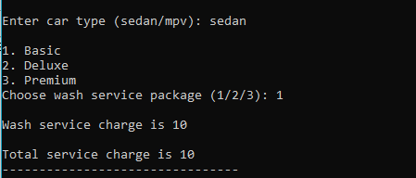
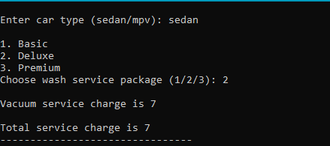
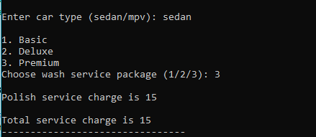
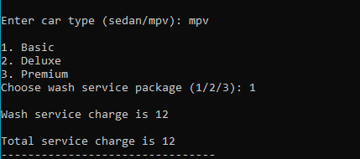
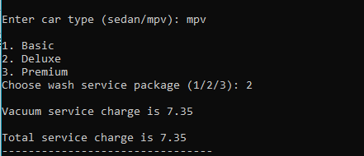
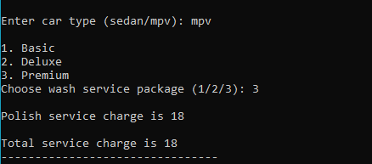
Note: show user’s input.

#include <iostream>
#include <string>
using namespace std;

// constants with the associated values
#define WASH 10.0 // the price of WASH service charge
#define VACUUM 7.0 // the price of VACUUM service charge
#define POLISH 15.0 // the price of POLISH service charge

// Task 6: List all function prototypes.

// Task 7: (i) Call the functions from Task 1 until Task 5.
int main() {
string carType; // car type variable
int wsPkg; // car wash service package
float totalCharge = 0; // total service charge based on different wash service package with different car type

// call setType function with the parameter carType

// call setPackage function with the parameter wsPkg

// Task 7: (ii) totalCharge is the variable to hold the total service charge based on different wash service package with different car type (sedan or mpv).
switch (wsPkg) {

}
cout << endl;
cout << "Total service charge is " << totalCharge;
return 0;
}

// Task 1: Function to set car type
void setType(string &type) {

cout << endl;
}

// Task 2: Function to set wash service package
void setPackage(int &pkg) {

cout << endl;
}

// Task 3: Function to determine exterior wash service charge based on car type
float wash(string type) {

}

// Task 4: Function to determine interior vacuum service charge based on car type
float vacuum(string type) {

}

// Task 5: Function to determine exterior polish service charge based on car type
float polish(string type) {

}

